1关键词汇

electrolyte 电解质 zwitterion 两性离子 vessel 血管

2计算

1ppm=1mg/l 1meq=1mmol/l 注意w/w质量浓度 w/v质量浓度 v/v体】

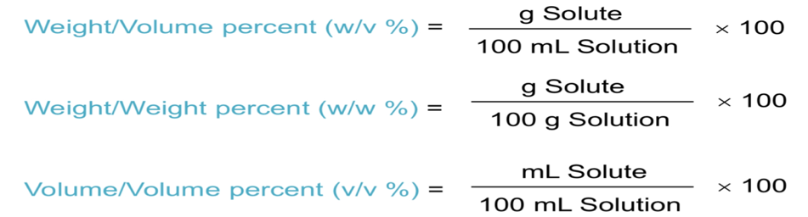

3监管部门

ema欧洲 nmpa中国 fda美国

**lifestyle drug and therapeutic drug区别**

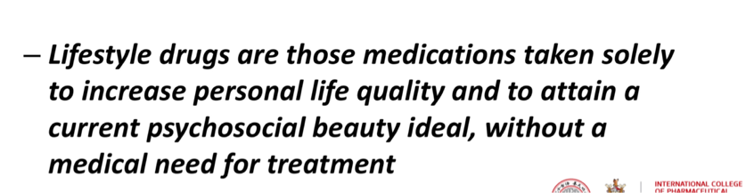

**4定量吸入器工作原理**

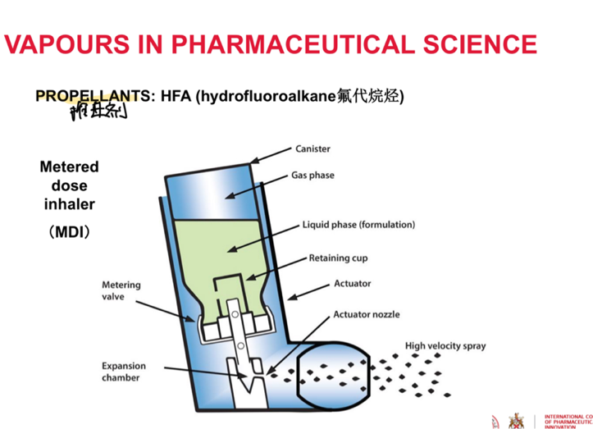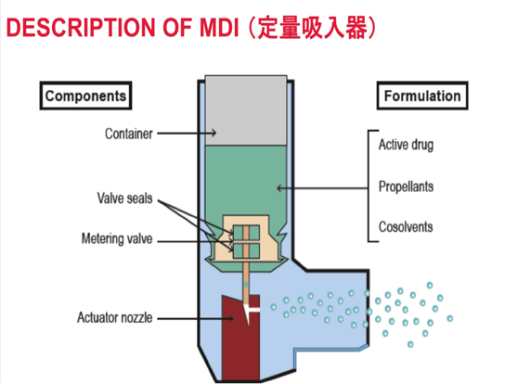

5栓剂形状与功能

在此处输入摘要、注释等，你可将文本框放置在文档的任意位置。

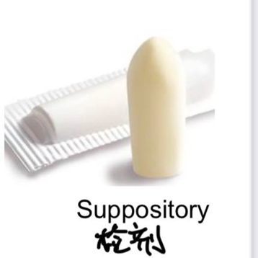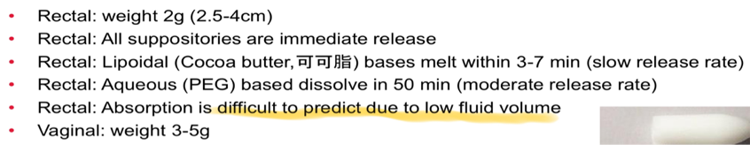

6不同注射方式

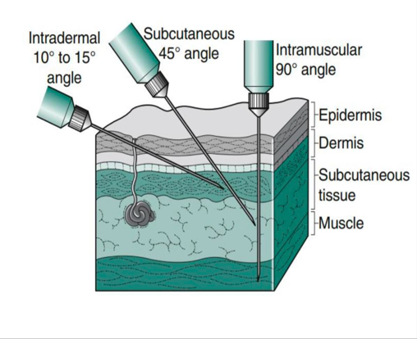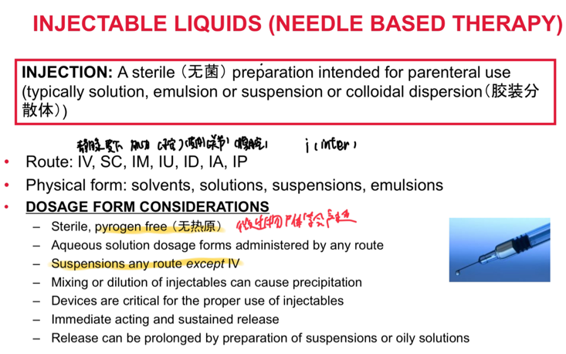

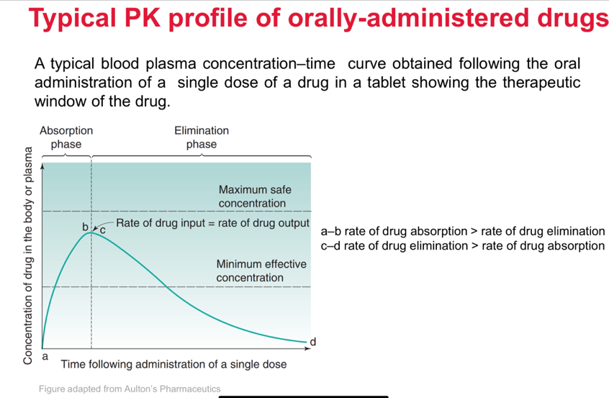

7不同的给药路径与优缺点

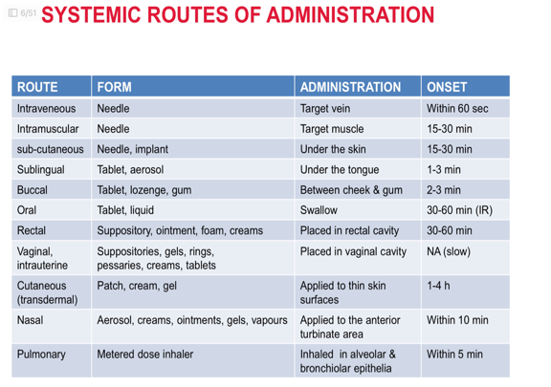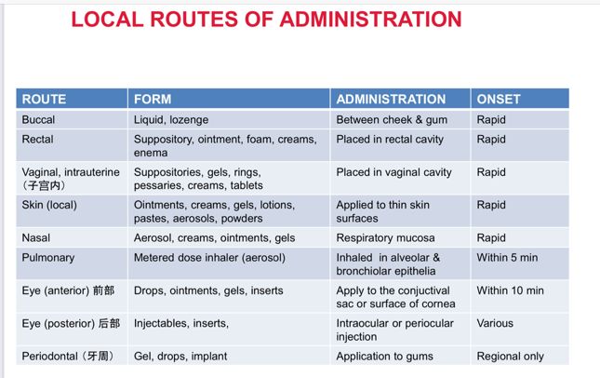

口腔：方便，安全，最常见 有首过效应，可能作用部位浓度低，酶可能降解药物

直肠给药：容易给药，无首过效应 错误使用任然有首过效应，依从性低，接受度低，长期不方便，效果难以预测

阴道给药：副作用小，效率高 只可以女性，容易但不方便

肺部给药：对一些病效果很好如哮喘，可局部也可系统给药 效果难以预测

注射：浓度高，快速，剂量小 不能有空气，静脉炎，颗粒大小要求,专业人员，疼痛

鼻部：局部和系统，给药方便，作用快速 作用效果难以预测，药停留时间短，局部刺激

眼部给药：剂量控制，药剂递送难

理想的药物形式

• One dose in a manageable size unit

• Palatable （可口的） and comfortable

• Stable (chemically, physically and microbiologically)

• Convenient and ease to use

• Release of the drug to the receptors in a timely fashion with minimal side

effects for the optimal duration最佳持续时间

8影响给药方式的因素

(1) Nature of the condition病的种类，严重程度会影响局部给药或者系统给药

(2) Minimal side effects浓度的控制

(3) Convenience and ease (patient compliance/adherence)技术上，生理上（如难以吞咽），副作用，

(4) Administration at convenient 给药频率和剂量，是否要注意饮食饭前还是饭后

(5) Potency 效力and efficacy功效 达到药效所需要的剂量，和给的药能达到的最大效果

(6) Onset of action起效时间

(7) Biopharmaceutic consideration (liberation and absorption)理化性质很重要（膜的吸收性，血流量，生理环境）

(8) Cost and manufacturing requirements

(9) Disease states

(10) Therapeutic considerations

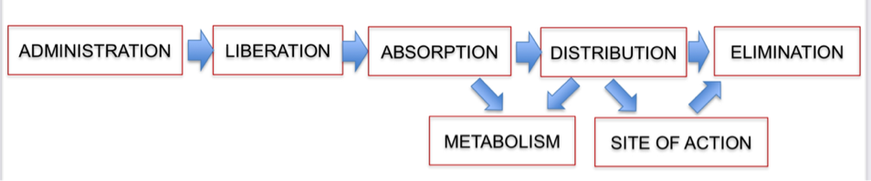

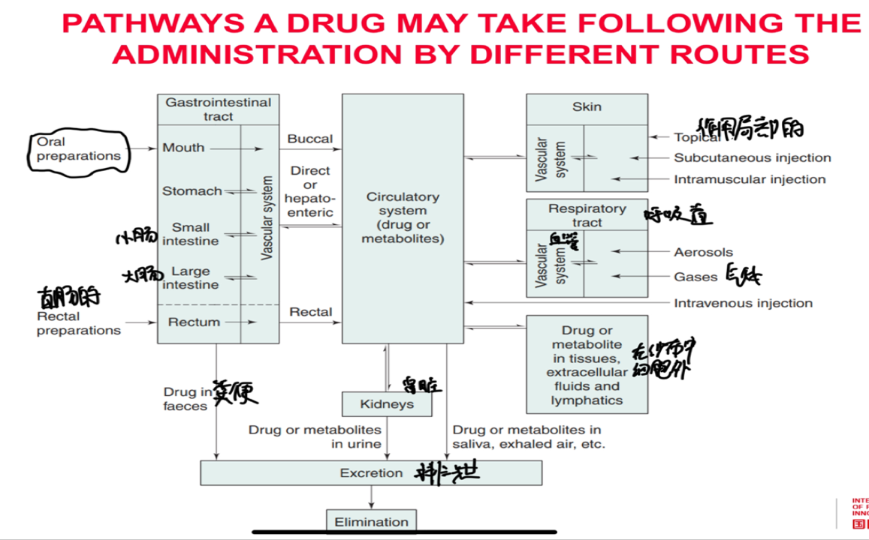

KEY DRUG PROPERTIES THAT INFLUENCE DOSAGE FORM DESIGN

(1) Water Solubility and dissolution (D, pKa, crystal properties)

(2) Lipophilicity (Log P, Papp)

(3) Molecular weight

(4) Organoleptic （感官的） properties

(5) Stability (chemical/physical/biological)

(6) Location of target receptors

(7) Selectivity

(8) Processing stresses (e.g. mechanical, pressure, temperature)

(9) Manufacturing procedures (e.g. granulation（颗粒化）, compaction压缩, autoclaving高压灭菌）

9溶液胶体悬浊液区别

Solution（溶液）: Is a mixture of two or more components that form a single phase that is homogeneous down to the molecular level (dimensions <1nm)

Colloid（胶体）: Fine dispersions where dispersed particles fall within the size range of 10-9 m (1nm) to about 10-6 m (1μm)

Suspension（悬浮液）: Coarse dispersions of finely divided discrete solid particles dispersed in a second solid/liquid continuous phase (dimensions >1μm)

Emulsion乳剂（乳剂定义是重点） is a coarse dispersion of liquid droplets液滴 dispersed with a second liquid continuous phase (dimensions >1μm）

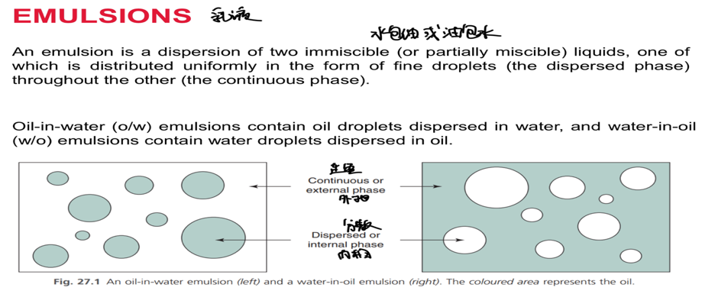

10固态液态气态区别

固态

A solid state of matter results when attractive forces exceed repulsive forces between molecules or ions

A given mass of solid at a given temperature and pressure has a defined volume and keeps its shape, provided there are no external forces (shear)

• Difficult to compress

• Fix position with no diffusion

• Generally higher density than liquid form (except H2O)

• Most drugs exist in the solid state (e.g. paracetamol对乙酰氨基酚)

• Two common solid forms

– AMORPHOUS FORM 非晶型(Glass, plastics)

– CRYSTALLINE FORM 晶型(ice, NaCl)

液态

Liquid has a defined volume at a given temperature and pressure but in contrast to a solid can take the shape of the container that it is placed in

• Difficult to compress （压缩）

• Fast diffusion

• Generally lower density than solid phase (except H2O)

• Examples: Water, ethylene glycol 乙二醇, mineral oil 矿物油, ethanol

半固体semsolid

Semi-solids exhibit behaviours with characteristics of solids and liquids

•Can maintain shape and volume

•Examples: white soft paraffin （WSP，白色凡士林）

• Normally viscous （粘性的） unctuous （油性的） mass

• Problematic in solid dosage forms

气态

• Gases do not have a fixed volume or shape and will occupy each volume that is available to them, and have a very low density depending on the space available to them

• Rapid diffusion （扩散）

• Examples: O2 CO2

• Gases exist in rapid motion and resultant collisions （碰撞） with the walls of a container gives rise to pressure (F/A）

蒸汽vapour

• A vapour is the gaseous form of a substance that concurrently （同时地）exists in the liquid or solid forms (below the critical temperature临界温度)

– Solid: Iodine, Camphor（樟脑）

– Liquid: Water, ethanol, essential oils（精油）, nicotine

• Water evaporates and exists at a specific vapour pressure in the atmosphere

• High vapour pressure: High propensity （倾向）to evaporate and exist in the gases phase

11溶解度定义

Solubility: is the maximum concentration of a substance that will dissolve in a given solvent (usually water) at a given temperature

KEY POINT: Although the concentration of most drugs is expressed as using weight in a specified millilitres of solution, the solubility of most drugs is expressed using weight in specified millilitres of solvent

Solubility is an important parameter参数 that often governs BIOAVAILABILITY

12影响溶解度因素

• Temperature and heat input.

• Molecular structure of solute.

• Nature of solvent: cosolvents： ‘like dissolves like’.

• Crystal characteristics: polymorphism（多态性） and solvation（溶解）.

• Particle size of the solid.(surface free energy)

• pH.

• Common-ion effect (同离子效应）

13熔点与溶解度关系

Melting point is a measure of the strength of interactions between molecules in a solid and of drug-drug attractive forces. The lower the melting point the lower the attractive forces which confers greater aqueous solubility in

any solvent.

Melting point is a good predictor of molecular cohesion and solubility of solids

Boiling point is a good predictor of molecular cohesion and miscibility of liquids

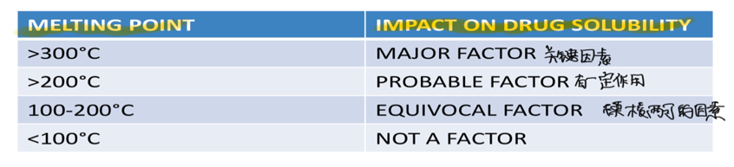

14晶体多态性

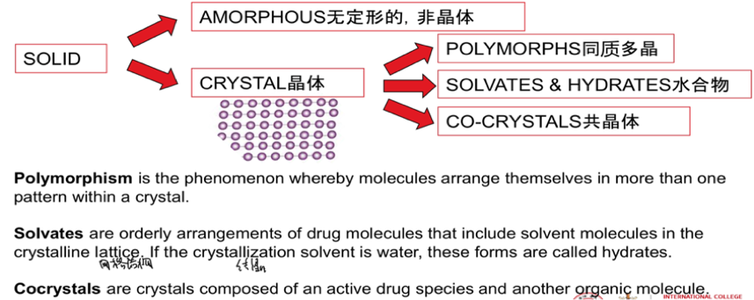

共晶体定义是重要定义

POLYMORPHISM同质多晶

POLYMORPHISM: Is the phenomenon whereby molecules arrange themselves in more than one pattern within a crystal• Regulators typically approve one crystal form (other forms metastable亚稳态 )

• The most stable crystal form will have the highest melting point

• Polymorphism is difficult to predict

• Approximately 36% of marketed drugs exhibit polymorphism

• Polymorphisms typically have different crystal habits（晶体惯态）

• Polymorphic behaviour Is a major concern of the pharmaceutical industry because it has considerable formulation, therapeutic, legal, and commercial implications.

Polymorphism can influence the melting point, solubility, dissolution rate and bioavailability of a drug, and processing properties such as powder flow and compressibility.

➢ There will be one polymorph in which the intermolecular attractive forces are best aligned 对齐的and it will be the most thermodynamically stable. This form of the drug is the highest melting and the least soluble in any solvent.

➢ Less stable polymorphs can spontaneously convert to the more stable form over time.

➢ Because polymorphs have different physical properties they offer the opportunity

➢ Polymorphism can complicate the preparation of suspensions because as the to select a lower melting point and therefore a more soluble form of a drug for use in a solid dosage form.

drug moves in and out of solution it will ultimately re-form in the most thermodynamically stable and least soluble form.

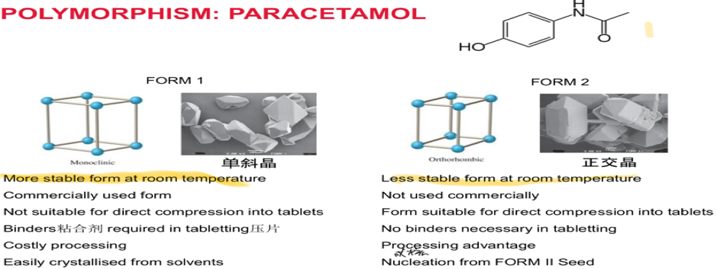

15无水化合物和水合物(水合物更加稳定溶解度和利用率会下降）

ANHYDROUS无水的: Solid devoid of water in its solid structure

HYDRATES水合物: When the solvent that is incorporated into the crystal lattice

is specifically water, the solvate is called a hydrate

• Approximately 30% of drugs form hydrates

• 50% of hydrates are monohydrates 一水合物(Drug:Water 1:1)

• 20% of hydrates are dihydrates二水合物 (Drug:Water 1:2)

• Hydrates can lose water of hydration, becoming sticky (efflorescence风化)

16吸水性与潮解HYGROSCOPICITY AND DELIQUESCENCE

Hygroscopic powder: Take up water from the atmosphere.

• Deliquescent powder: Sorption of water vapour from the environment and gradually form a solution that impacts the chemical stability of the drug or excipient

• Drugs and excipients with polar surface groups will adsorb a layer of water on their surface , particularly if their surface is large

• Metal salts are prone to hygroscopicity (Na+, K+, Ca2+, Mg2+)

• Desiccants （干燥剂）can be added

17晶体最小单元

UNIT CELL（晶胞）: A unit cell is the simplest repeat unit in a crystal.

CRYSTAL LATTICE晶体点阵（晶格）: Is an orderly three dimensional arrangement of molecules (unit cells) that permits optimal attractive interactions between adjacent molecules within a solid

CRYSTAL HABIT（晶体惯态，晶习）: Is a term used to describe the shape of the drug crystal that can be appreciated by visual inspection

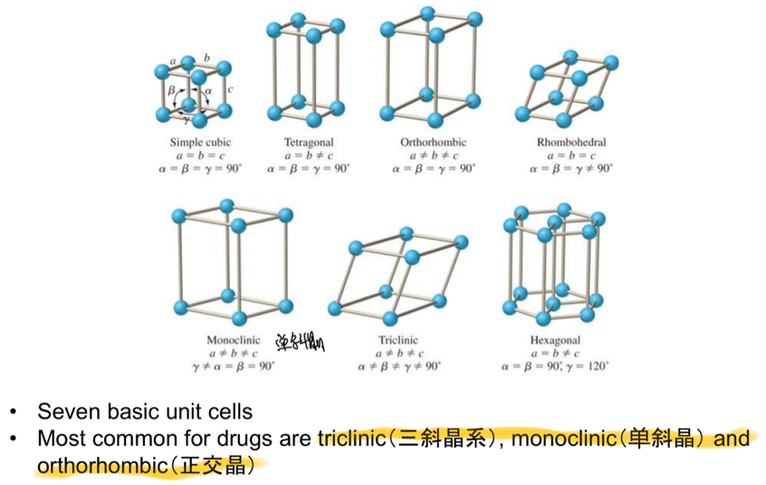

CO-CRYSTALS共晶: Crystals composed of active drugs species and another organic molecule

• Co-former: The other molecule H-bonds with drug providing a lower melting point and a more soluble solid than the pure crystalline form

• Generally GRAS一般认为安全（Generally Recognized as Safe）

• Examples: caffeine, vitamins, adenine腺嘌呤, cytosine胞嘧啶

• Co-crystals can be more stable than polymorphs, reduce stability concerns.

AMORPHOUS SOLIDS（非晶体）

PUT SIMPLY, AMORPHOUS MATERIALS ARE SIMPLY A PILE OF MOLECULES• Many polymers are amorphous materials

• Many excipients are amorphous materials

• Crystalline solids can be processed into amorphous form which lowers the melting point and improves solubility

– Processes: micronisation微粒化, milling碾磨, freeze drying, spray drying喷雾干燥

– E.g. when a drug solution is cooled so rapidly that they lose conformational mobility prior to forming their lattice (freeze drying)

• Porous low density materials susceptible to sorption of vapour

• Many drugs used in orally disintegrating tablets are amorphous forms of the drug to improve solubility, but require individual packaging to avoid adsorption of moisture

Tg: Is the temperature below which the material is said to be in a glassy state and is brittle（易碎的）; above the Tg the molecules become more mobile and molecules are more rubbery（有弹力的）

18热力对溶解度的影响

ENDOTHERMIC 吸热的 DISSOLUTION

• Heat is absorbed during dissolution

• Positive H:  temperature =  solubility

EXOTHERMIC 放热的 DISSOLUTION

• Heat is evolved during dissolution

• Negative H:  temperature =  solubility

Generally dissolution/diffusivity of solid in liquid increases by raising the temperature of the solvent, however, there may be lower solubility which can lower dissolution and solubility

Heat can also accelerate degradation降解

19电解质定义

Electrolytes: Are substances that dissociate into their constitutive ions when dissolved in a suitable solvent. Dissociated species are ionised, and therefore solutions of electrolytes conduct electricity.

– 75% of drugs are weak electrolytes 弱电解质

– 25% are non-ionic or amphoteric 两性的

• Non-electrolytes and the solubility of electrolytes

• Addition of non-electrolyte to sparingly soluble （难溶的）electrolyte solution lowers dielectric constant（介电常数）,hence solubility decreased

• Electrolytes and the solubility of non-electrolytes

• Very soluble electrolyte will reduce the solubility of non-electrolyte

SALTING OUT（盐析）

• Precipitation of organic solutes from aqueous solution by the addition of an electrolyte or salt

non-electrolyte (q) + Ion → Ion (aq) + non-electrolyte

SALTING IN（盐溶）

• Increase in solubility of an organic solute upon addition of an electrolyte(unusual and poorly understood phenomenon）

20利平斯基五定理LIPINSKI'S RULE OF FIVE经验性原则，至少满足两个才可以口服

• No more than 5 hydrogen bond donors (the total number of nitrogen–hydrogen and oxygen–hydrogen bonds)

• No more than 10 hydrogen bond acceptors (all nitrogen or oxygen atoms)

• A molecular mass less than 500 daltons

• A calculated octanol-water partition coefficient (Clog P) that does not exceed 5

杜适补充可旋转的键不超过五个，不然立体结构过于复杂

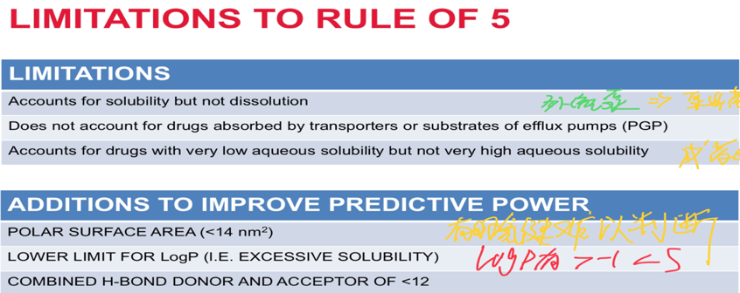

未考虑外流泵和载体

LogP>-1且<5

有时氢键的影响难以判断

成药与运输能力也要考虑

GENERAL SOLUBILITY EQUATION (GSE)溶解方程

Log S = 0.05 – 0.01 (Tm– 25) - LogP

S Intrinsic solubility Tm Melting point (ºC）LogP Partition coefficient (O:W)

• In cases where drugs have very low aqueous solubility correlation has been found to be better between Log S and Log P, but not Tm and S

21logp与logd的意义

p

Log partition coefficient (LogP): Is parameter that estimates whether a drug will prefer to interact with water or prefer to escape water and interact with an immiscible organic solvent (commonly n-

octanol正辛醇). It is the log of the drug concentration in solvent divided by the drug concentration in water. (p=c0-cw)

运用p

• According to the USP definition of solubility, drugs that have a Log P of < 0.5 are water soluble

• The power of log P lies in its ability to predict partitioning into biological membranes

• Tangible correlation between Log P and binding to plasma binding proteins (such as serum albumin).

• Tangible 明确的 correlation between Log P and the activity of specific classes of preservative 防腐剂 (Preservative selection)

• Analytical method selection

• Drug adsorption behaviour (to plastic, glass, packaging)

logd的运用logd更加全面

• Log P does not account for pH dependent partitioning

• Log D accounts for pH dependent partitioning（区分）

Log DPH 7.4 = [Ionised + unionised]OCT/[Ionised + unionised]WATER

22酸碱理论

Arrhenius definition氢离子的变化

• Electrolytes ionise in solution

Bronsted Lowry definition质子的供体与受体

• Acids are proton donors • Bases are proton acceptors

Lewis definition电子受体与供体

• Acids are electron pair acceptors • Bases are electron pair donors

共轭酸conjugate acids. 共轭碱conjugate bases

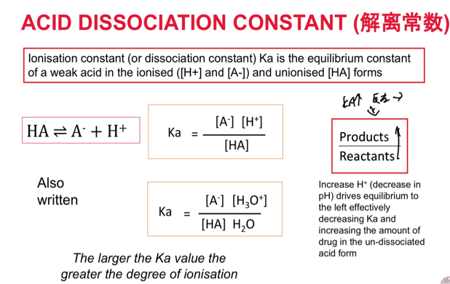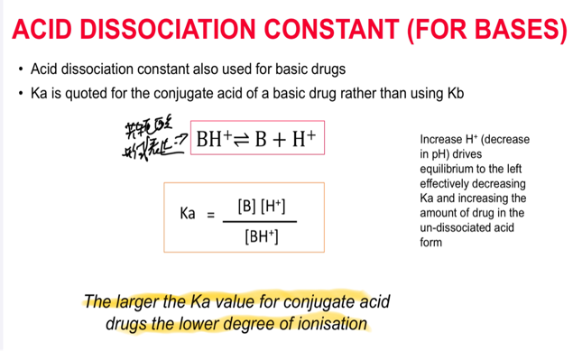

log Ka = log [A-] + log [H30+ ]– log [HA]. - log Ka = - log [A-] - log [H30+ ] + log [HA]

pKa = pH + log [HA]/[A-]. pH = pKa + log [A-]/[HA]

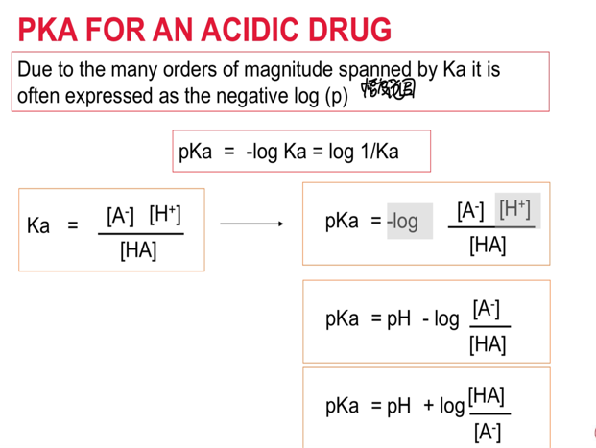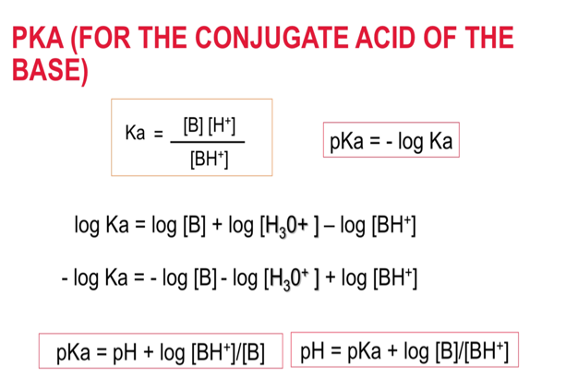

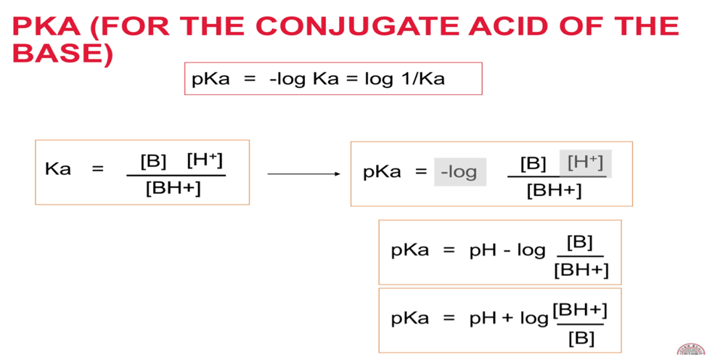

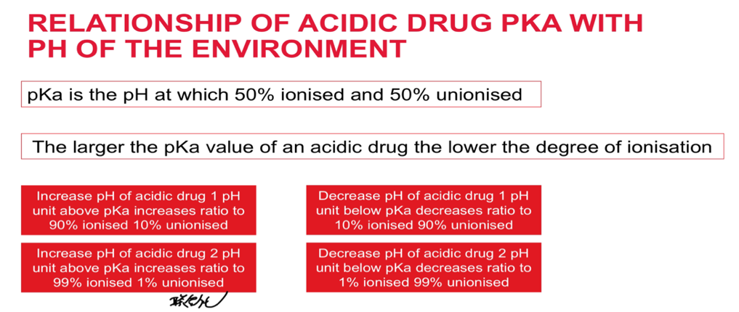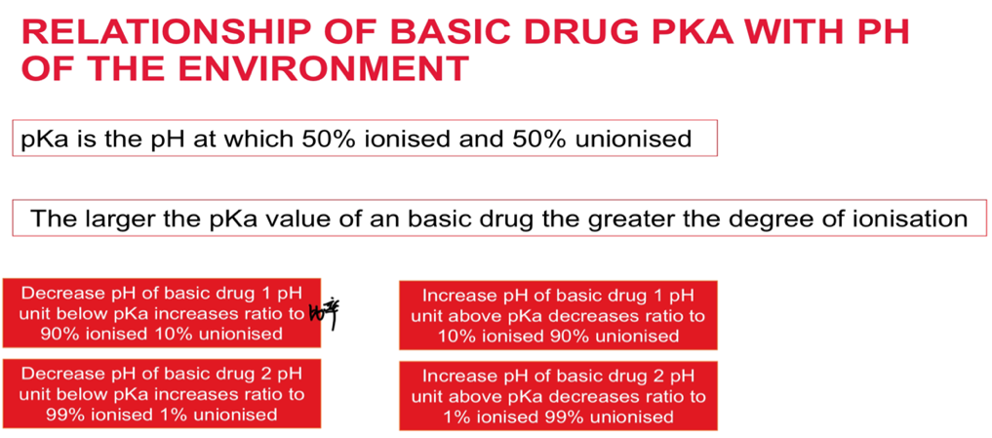

IONISATION AND SOLUBILITY在特定情况下相关

• Intrinsic solubility: solubility of an ionisable drug in the unionised [HA] or [B]

forms. Solubility of drugs greatly increases in dissociated charged form(cationic or anionic).

Solubility of acidic drugs increases above the pka

Solubility of basic drugs increases below the pKa

RELATIONSHIP BETWEEN PKA AND SOLUBILITY

St = S0 + Si Si = St- So

St So Si Total saturation solubility ([HA] + [A-] or [BH+] and [B])

Intrinsic solubility (Solubility of the non-ionised species [HA] or [B])

Solubility of the ionised species ([A-] or [BH+])

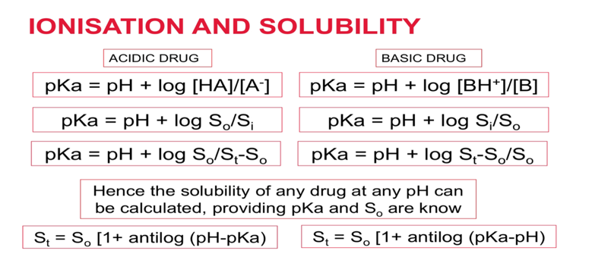

23两性药物

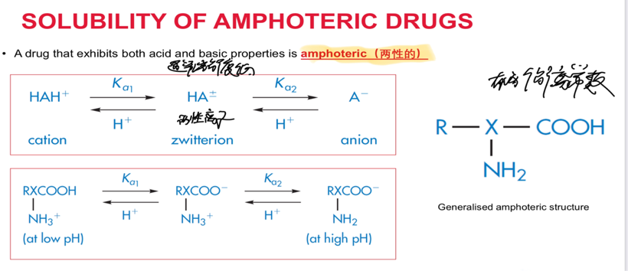

24一级与零级释放

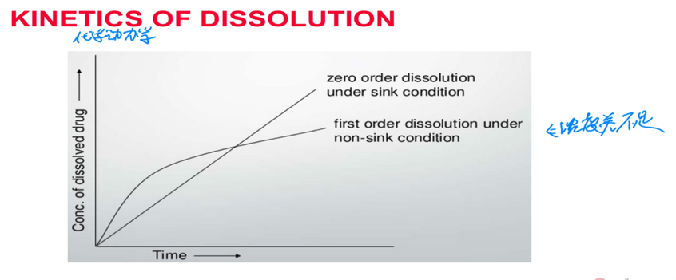

25溶出速率与漏槽条件

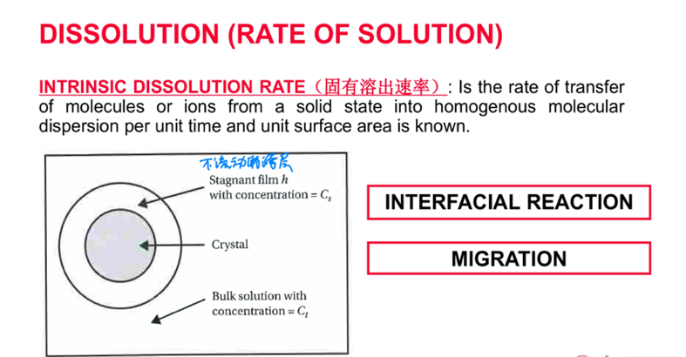

Interfacial reaction

1SOLUTE REMOVAL FROM CRYSTAL 2CREATION OF A CAVITY

3CAVITY INSERTION. 4DISSOLUTIN

Migration

This step is frequently the rate limiting step controlling the rate and extent of absorption.

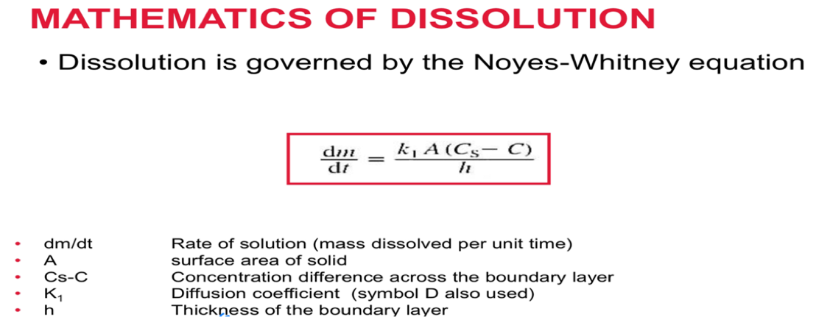

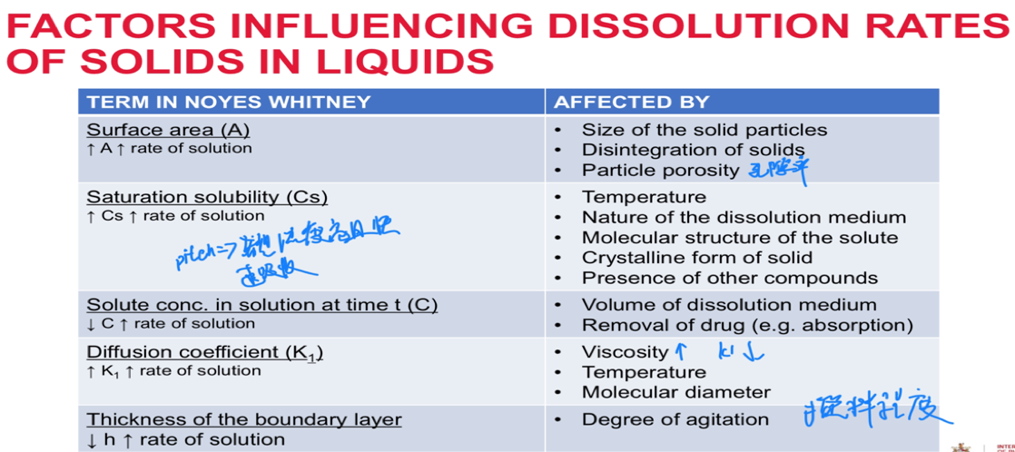

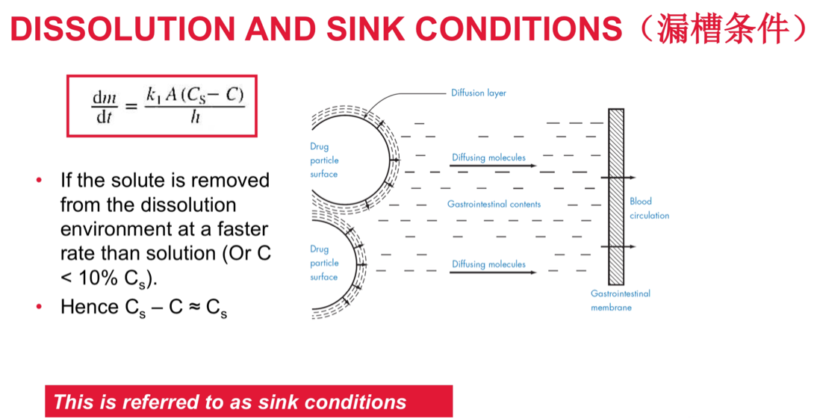

26上皮细胞种类及毛细血管

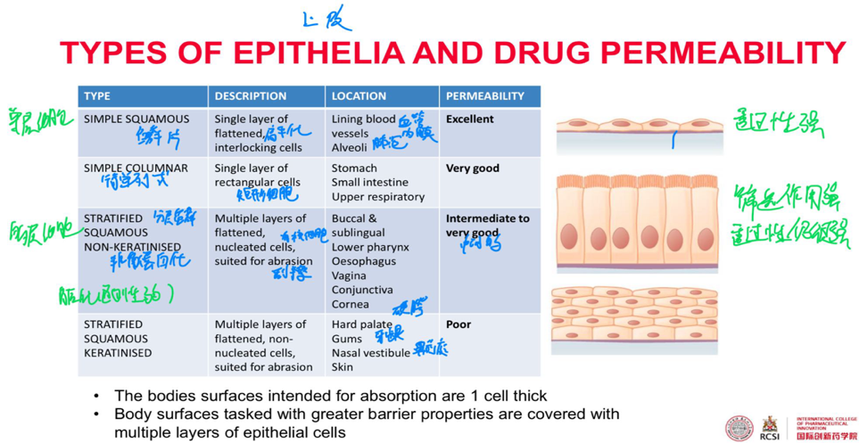

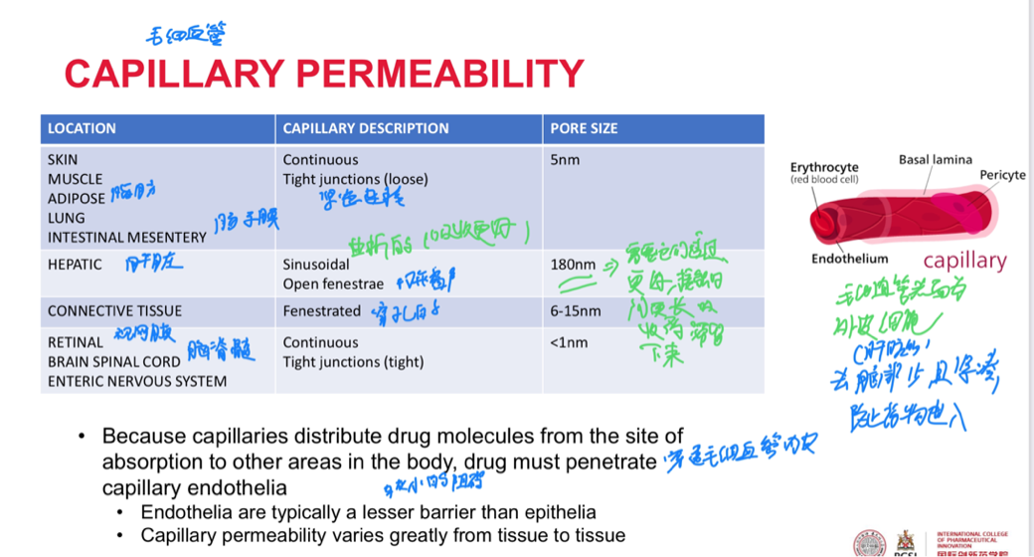

27穿过膜的不同方式

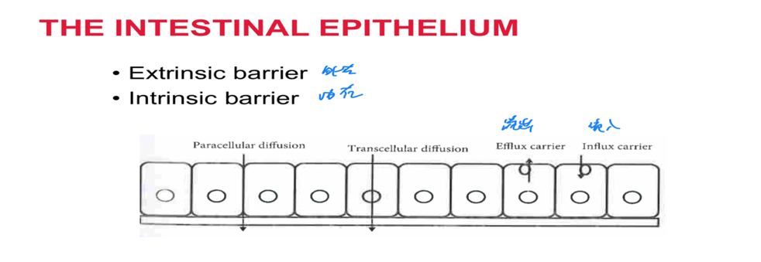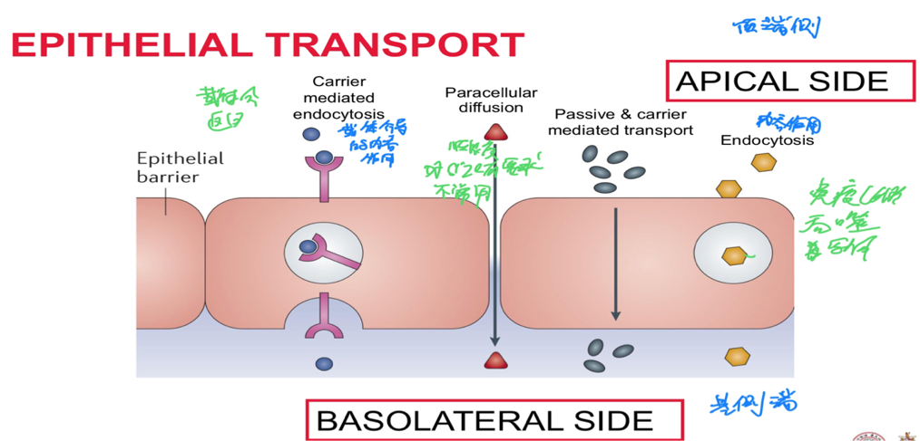  
TRANSCELLULAR ROUTE DRUG TRANSPORTERS

• Carrier mediated transport: Describes the movement of drug molecules bound to a specific protein site referred to as cell polarity saturable and somewhat structurally

– Protein carriers have evolved at some absorbing membranes such as the small intestine

– Apical极端侧 and basolateral surfaces have different transporter (and receptor composition) in what is referred to as cell polarity

– Some carrier mediated processes occur against a concentration gradient and therefore require energy

– Drugs that resemble nutrients (amino acids), may be assisted across absorptive membranes by influx transporters

– Saturable (and interactions both drug and diet)

– Some drug selectivity

c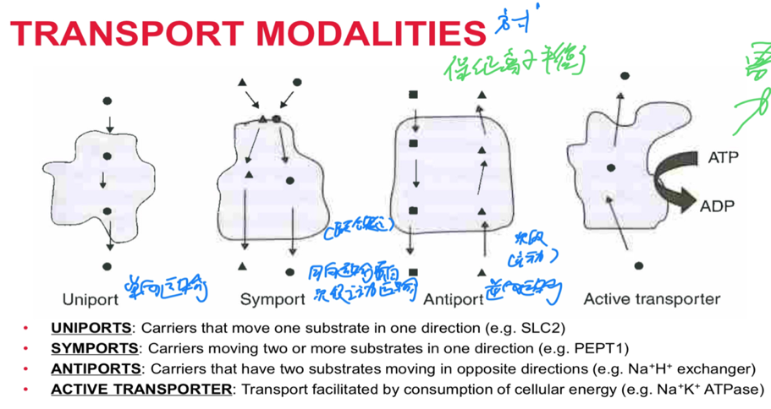

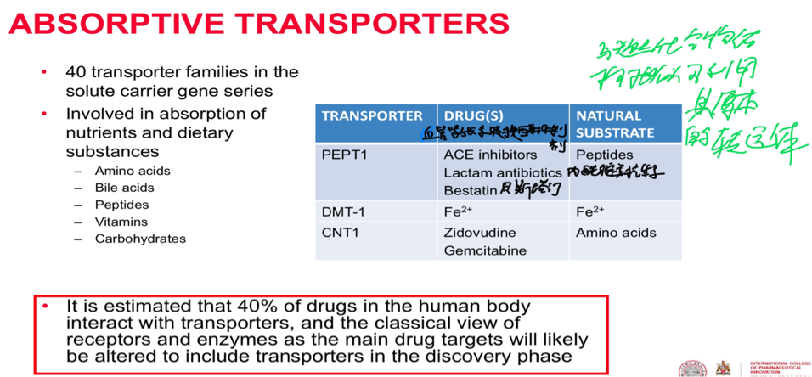

FLUID PHASE ENDOCYTOSIS: PINOCYTOSIS胞饮

• Pinocytosis: Is the engulfment吞没 of small droplets液滴 of extracellular fluid by membrane vesicles. Cells involved in internalisation of material will do so regardless of the metabolic importance to that cell.

• Molecule (and drug classes):Fat soluble vitamins A, D, E,K

RECEPTOR MEDIATED ENDOCYTOSIS胞吞（具有特异性）

• RECEPTOR:LIGAND complexes cluster on the cell surface and then invaginate 进入and break off from the membrane to form coated vesicles涂层囊泡

– RL interaction triggers a conformational 构象change in the membrane to initiate the process

– Coating is then lost and contents are delivered to cell compartments （e.g. Vitamin B12）

– Receptors are subsequently returned to the membrane

– Many endogenous 内源性substances e.g.insulin, epidermal growth factor, LH

PHAGOCYTOSIS吞噬作用（不具有特异性）

• Engulfment of particulates larger than 500nm by the cell membrane of intestinal epithelial cells

• Important in absorption of vaccines (e.g. oral polio) from the GI tract

Divalent metal transporter-1(dmt)二价金属转运体。唯一吸收亚铁离子载体

28葡萄柚果汁的影响EFFLUX AND GRAPEFRUIT JUICE

• Grapefruit juice contains a 会导致排出速率下降，药物浓度上升

number of flavenoids(类黄酮） that 不一定是好事，浓度过高可有毒

have an inhibitory effect on P-GP.

– A single glass of grapefruit juice can inhibit PGP for up to 24 h

– This can significantly alter the behaviour of medicines (e.g. A large increase in the absorption of cyclosporine)环孢素

– Potential to pharmacologically harness 结合PGP inhibitors 抑制剂to improve drug absorption

PARACELLULAR ROUTE

• Movement of water and low molecular weight aqueous solutes (<500 Da) occurs paracellularly through tight junctions (which open and close in response to stimuli刺激)

– Passive diffusion (no energy required, concentration gradient)

– Permeability is largely controlled by differences in tight junctions and paracellular permeability

– TEER 跨膜电阻is a measure of resistance to the flow of charge across epithelia and endothelia and thus provides an appreciation of paracellular permeability

– Lower TEER > permeability

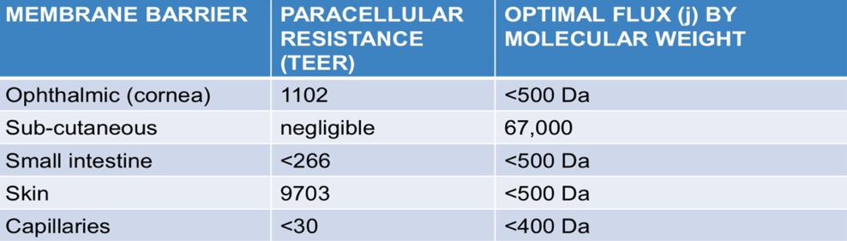

MOLECULAR BIOLOGY OF THE EPITHELIAL BARRIER：

PARACELLULAR ROUTE: TIGHT JUNCTIONS

• TIGHT JUNCTION: Multiprotein complexes that adjoin根部 adjacent epithelial cells

forming a seal 封闭that plays a critical role in maintaining polarity and barrier function.

TJ are modulated by chemical signalling processes and or exogenous外部的 ligands.

FOUR PROTEIN CLASSES

• TJ proteins (e.g. claudin)

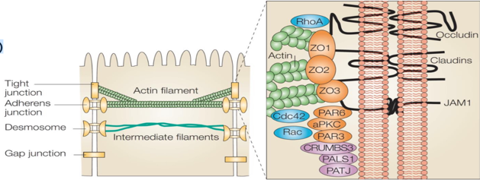

• TJ associated proteins (e.g. ZO-1)。

• Scaffolding proteins支撑蛋白 (F-actin)

• Signalling proteins (cingulin）

BLOOD FLOW: DIFFUSION DRIVES FLUX

• The CONCENTRATION GRADIENT between APICAL and BASOLATERAL side of the epithelium drives the passive diffusion and therefore intestinal FLUX流动 of all but a few drug

• If the drug is not rapidly removed from the basolateral基侧的 side (poor perfusion灌输), the rate and extent of absorption can be reduce

DRUG EFFLUX PUMPS

• EFFLUX PUMPS Are membrane transport proteins that actively pump drug out of cells in the same direction that they were absorbed, often against a concentration gradient. These pumps function to maintain a low intracellular concentration of drug.

• Various epithelial cells have efflux transporters that actively remove drug that enters the cell.

• Multidrug resistance (MDR) transporters pump 多药耐药性蛋白泵a wide range of structurally diverse drugs out of cells in an ATP dependent fashion.

– P-GLYCOPROTEIN p糖蛋白 is a common drug efflux pump confined to the apical membrane of epithelia.

– Expression increases at the tips of villi绒毛

– Broad substrate specificity特异性

– Cationic and lipophilic drug are more common targets but can efflux other drug types

– 300-2000 Da

29脂溶性和水溶性对药物溶解度的影响（与前面五规则也有关）

BIOPHARMACEUTICS CLASSIFICATION SYSTEM

• Biopharmaceutics classification system: Is a scientific framework for the classification of orally administered drugs based on two key metrics指标

BSC Class

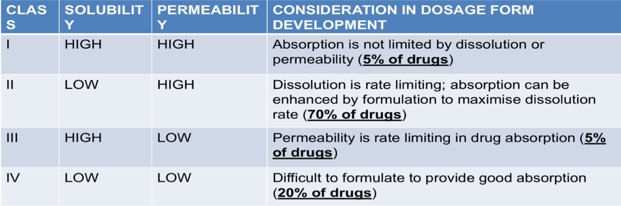

BCS CLASS I IS THE IDEAL DRUG CLASS

SOLUBILITY IN BCS

• HOW MUCH SOLUBILITY IS ADEQUATE

• A Drug is defined as HIGH SOLUBILITY if the highest dose strength will dissolve in < 250 mL of water over a pH range of 1-7.5 at 37ºC(胃容量的一半，喝一次水的量，需要的药量在250ml内溶解即可）

• We therefore take into account dose when considering solubility, rather than using simple solubility metrics alone

• The FDA defines HIGH PERMEABILITY as the extent of absorption in humans greater than or equal to 90%（等价于生物利用度90%）

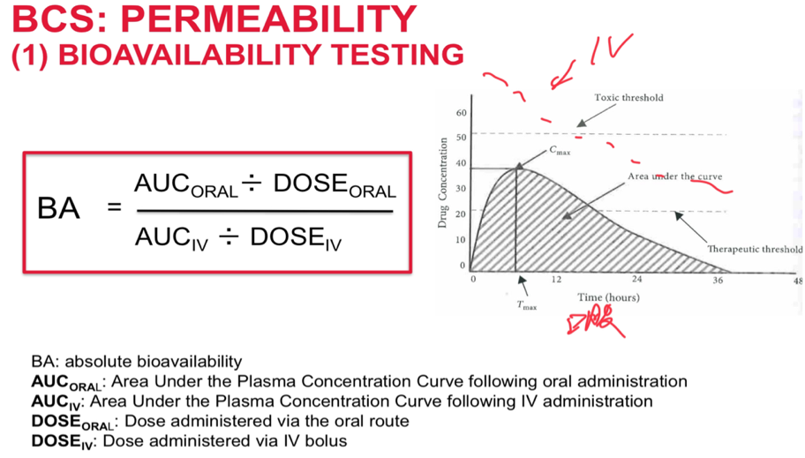

Bioavailability(F)=直接给药和IV给药浓度的比（iv）接近100%

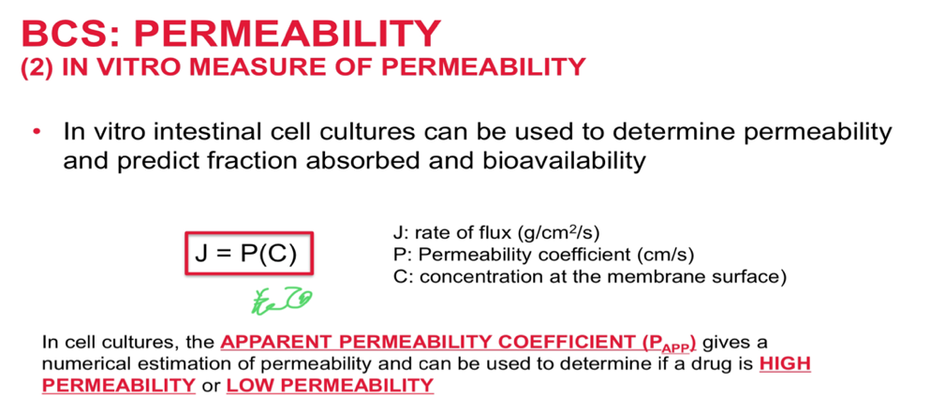

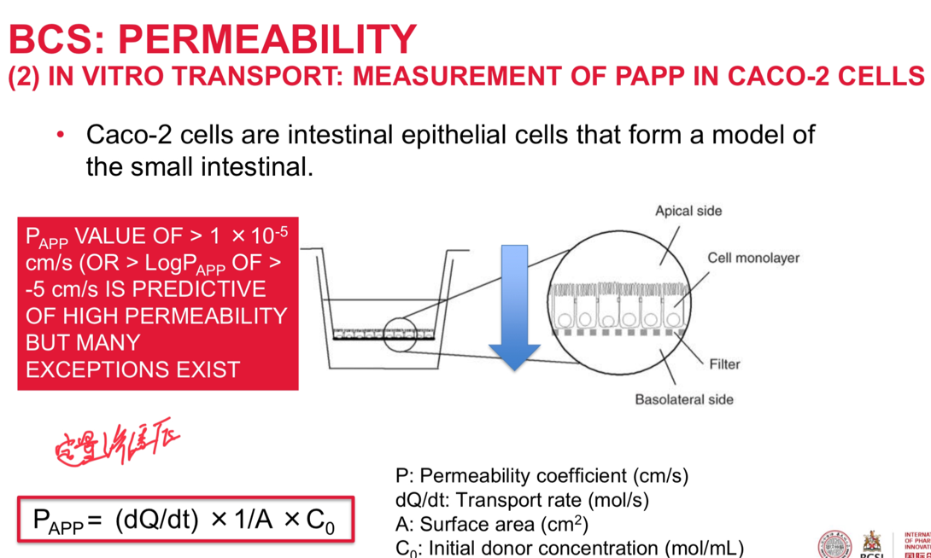

BCS: PERMEABILITY

• Permeability data is not widely published for drugs

LogP can be used to substitute Papp which is effective approximately two thirds of the time

• As a guide, drugs with LogP >2 and <5 are likely to have good permeability and adequate solubility, nevertheless total number of H-bonds, molecular weight and pKa

DEVELOPABILITY CLASSIFICATION SYSTEM (DCS)更考虑生理性质而不只是理化性质

• DCS has recently been proposed to apply the BCS as an oral product development tool. In this model

– BCS Class II is divided into dissolution rate limited and solubility rate limited

– Dissolution is expressed as target particle size (Vs dose/solubility)

– Dissolution is measured in FSSIF (Vs HCl)

– Solubility is measured in 500mL volume (Vs 250mL in BCS)

• DCS is a simple system that aids the product design scientist in understanding the absorption limitations for a drug. Once identified, these limitations can be addressed

30提高溶解度的方法

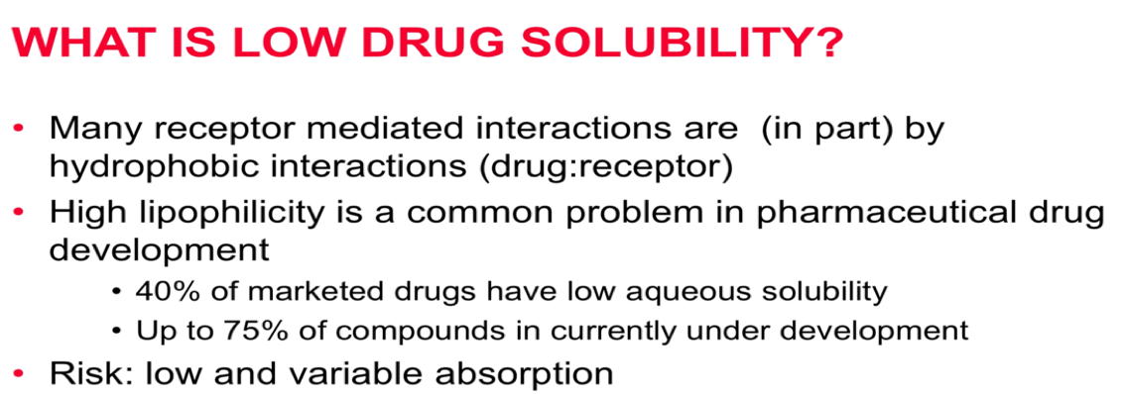

STRATEGIES TO ENHANCE SOLUBILITY

1. MANIPULATION OF pH（75%weak bases 20%weak acids 5%amphoteric)

2. SALT FORMATION (可以增加或减少溶解度（erythromycin stearate硬脂酸盐，），不同盐型是不同药物,理化性质一般不同，可作为PH adjustment，）（缺点：PH值过高或者过低时可能会回到分子型式，同离子效应）安全考虑最重要

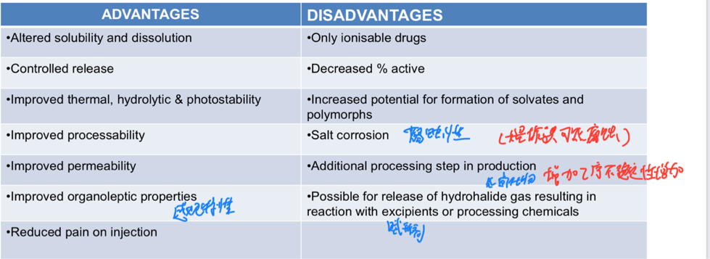

1. CRYSTAL ENGINEERING

Any manipulation that results in altered crystal packing

– Traditional approaches: salt, solvate,

polymorph screening（提高可以增加有序性，可适当提高溶解度）

– Recent approaches: cocrystals（Mixed crystals consisting of two or more molecular species (that alone are solid at ambient conditions) held together by non-covalent and non-ionic forces）

Some coformers can also lower the solubility

– Particle engineering

1. PARTICLE ENGINEERING

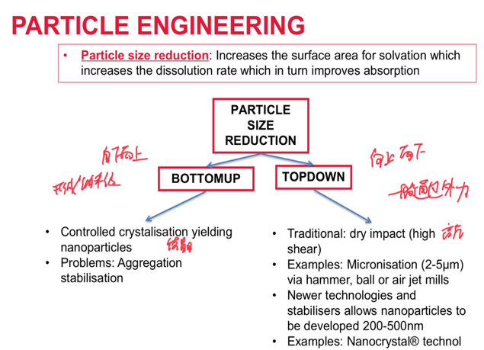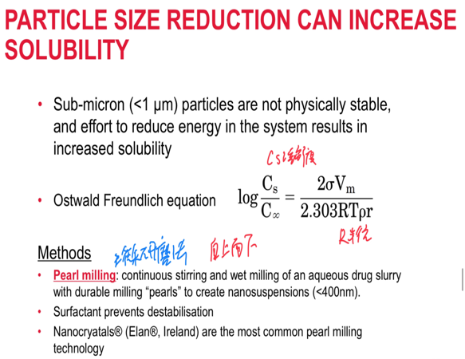

5. CO-SOLVENCY(共溶剂进入体内平衡会被打破，如果在某一种溶剂中溶解度低可能会快速析出，有危险，特别是静脉注射）

6. SOLID DISPERSIONS稳定性可能问题

relatively few marketed products

• Drugs are dispersed within a carrier matrix (e.g. HPMC, PVA) that can attenuate drug

recrystallization (via reduced mobility or bonding with drug）

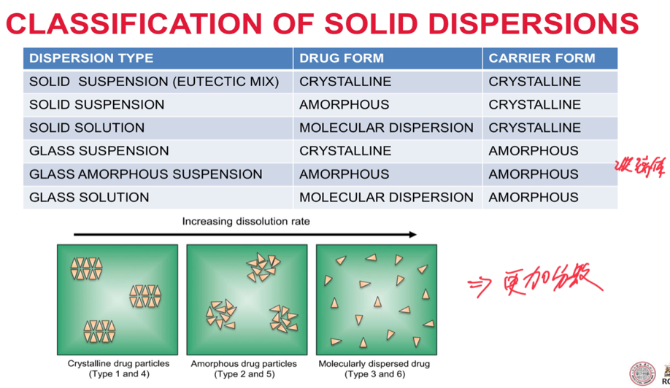

途径

• REDUCED PARTICLE SIZE

• IMPROVED WETTING

• ENHANCED SOLUBILISATION

• REDUCED LATTICE ENERGY

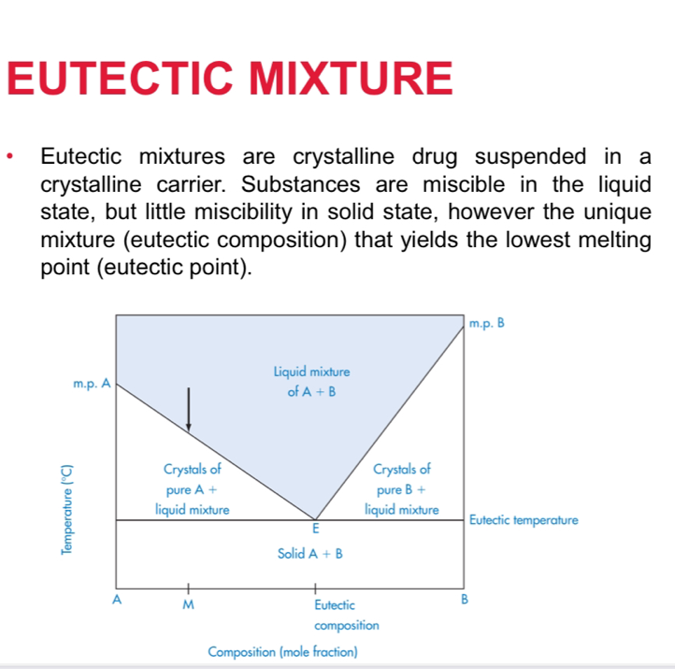

E点取决于A和B的比例

可以减小制备难度，提高稳定度

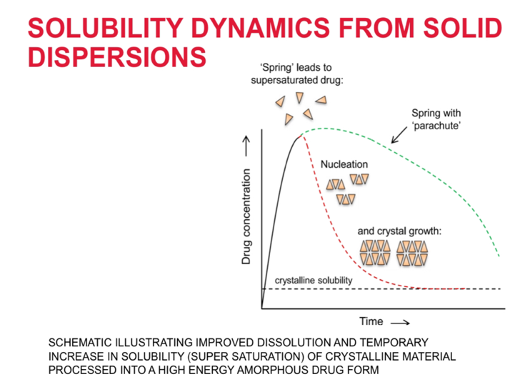

绿：降落伞过程

红：在体内浓度可能会骤降导致快速析出

本质是高能状态到低能状态

1. SURFACTANT SOLUBILISATION（既有亲水端又有亲脂端）安全性：会对膜有影响有hypersensitive敏感 reactions，稀释可能会沉淀

micelle胶束At a specific concentration soluble surfactants will associate into spherical 球体aggregates called micelles. Micelles provide a nandroplet oil core that permit solubilisation of drugs

1. PRODRUG药物前体

• Pro-moieties that increase solubility: phosphate, sulphate, succinate

• Ester linkage is the most common (hydrolysis or esterase activity)

1. DRUG DERIVATION药物衍生物

• Functional groups: hydroxyl, carboxyl, primary & secondary amines

1. LIPID BASED FORMULATIONS利用体内本身存在的机制运输药物，主要提高脂溶性物质的溶解度

• LBF are not simply solutions or suspensions, rather lipid dispersion (micellar胶束, microemulsions 微乳液or coarse emulsions粗乳液

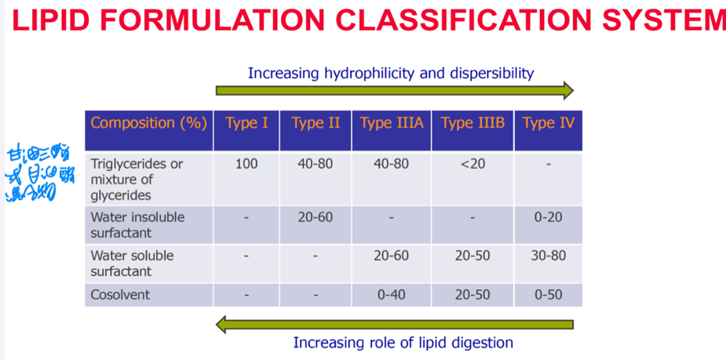

11.LIPID-BASED DRUG DELIVERY SYSTEMS

12.INCLUSION COMPLEXES

31环糊精cyclodextrins（CD）

多个多糖带形成的类似桶状结构，无法确定合成的化合物准确的结构

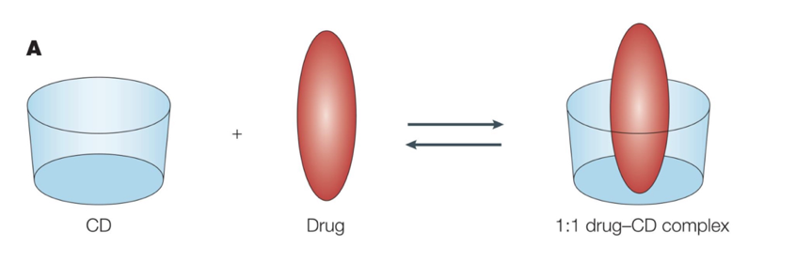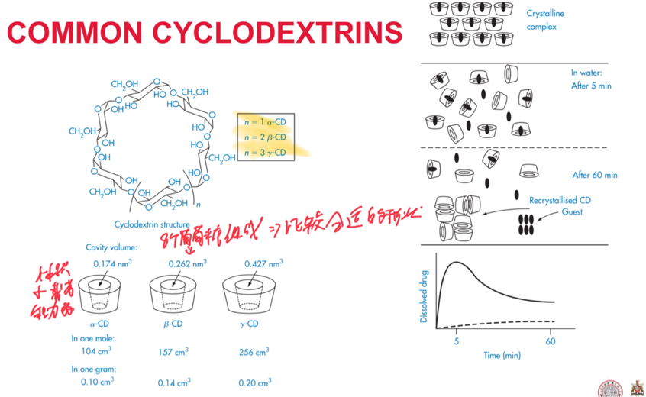溶解度由CD决定

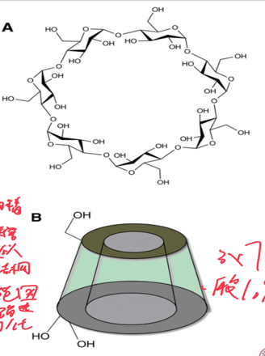

1. EMERGING STRATEGIES

• CARRIER ADSORPTION载体吸收

• SOLID LIPID NANOPARTICLES固体脂质纳米颗粒

32定量与定性分析的区别

• QUALITATIVE ANALYSIS: Analysis of a substance in order to ascertain the nature of its chemical constituents

• QUANTITATIVE ANALYSIS: Analysis of a substance to determine the amounts and proportions of its chemical constituents

33辨别accurate和precision

• ACCURACY: Closeness of a measurement to the true value数据与真实值的差距

• PRECISION: Closeness of two or more measurements to each other. The precision of an analytical procedures expresses the closeness of agreement (degree of scatter) between a series of measurements obtained from multiple sampling of the same homogenous sample under the prescribed conditions验证可重复性，数据与数据间的关系

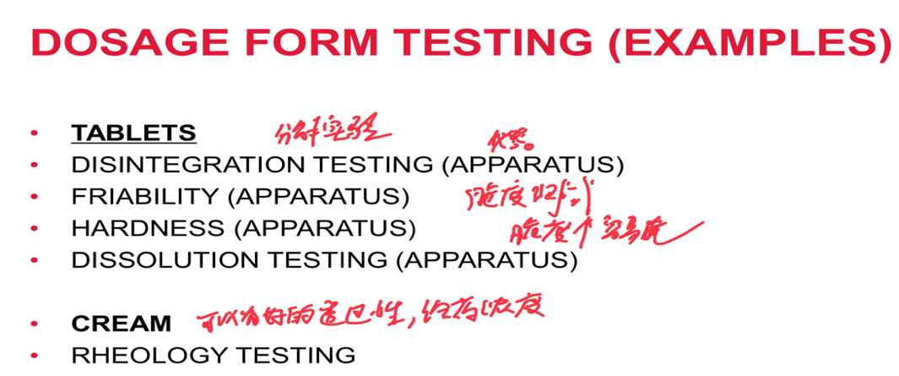

34不同分析方法的原理

TITRIMETRIC AND CHEMICAL ANALYSIS METHODS滴定法

• PRINCIPLE: An analyte is chemically reacted with a standard soluton of reagent of precisely known concentration, the amount of which is used to estimate the purity of a sample.

• Applications

• Assay of drug, excipient and some formulations

• Specialist applications (e.g. Karl Fischer)

• Adv

• High precision, accuracy, robust, cheap, automatable, no calibration

• Limitations

• Non-selective, skilled operator

• Large amounts of sample and reagent

ULTRAVIOLET AND VISIBLE

• PRINCIPLE: Radiation in the wavelength of 200-700nm is passed through a solution of a compound. The electrons in the bonds become excited so that they occupy a higher quantum state and in the process absorb some of the energy passing through the solution. The more loosely held the electrons the longer the wavelength (lower the energy)

• Application

• Widely used method of quantification

• pKa, dissolution, solubility, release kinetics, reaction kinetics

• Strengths

• Easy to use, cheap, robust, precision

• Limitations

• Moderate selectivity

• Not applicable to all solute

IR SPECTROMETRY

DETAILED IN PCP1A: IR SPECTROSCOPY

• PRINCIPLE: EMR ranging between 400 cm-1 and 4000 cm-1 (2500 nm to20000 nm) is passed through a sample and is absorbed by the bonds of the molecules in the sample causing them to stretch or bend. The wavelength of the radiation absorbed by the characteristics of the bond absorbing it

• Application

• Qualitative fingerprint check for excipients and drugs in manufacturing

• Preliminary compound identification

• Analysis in complex environments (creams, tablets etc)

• Detection of polymorphisms

• Strengths

• Complex fingerprint which is unique to the compound being examined

• Limitations

• Rarely used quantitatively due to sample preparation constraints

• Only useful for detection of gross impurities

• Technical knowledge required in sample preparation

MASS SPECTROMETRY

• PRINCIPLE: Analyte is subjected to chemical ionisation or electron ionisation and resulting charged species are then accelerated into a vacuum chamber and separated on the basis of their mass to charge ratio (m/z ratio). The charged species produced in the spectrometer will generally include a range of different fragment ions, and under the right conditions, will also include the molecular ion, which is simply the intact test molecule minus 1 electron.

• Applications

• Drug identification and characterisation (molecular weight determination)

• Characterisation of impurities (in conjunction with GC and HPLC)

• Bioanalysis (in conjunction with GC and HPLC)

• Proteomics

• Limitations

• Expensive instruments, complexity that requires highly skilled operators,

• Less widely used in QC

CHROMATOGRAPHY色谱法

• Chromatography is the most frequently use analytical technique in pharmaceutical analysis. Chromatography is the separation of the individual components of a mixture by exploitation of the difference in how analytes partition between a mobile phase and a stationary phase

• TYPES

• Column chromatography

• Thin layer chromatography

• Gas chromatography

• High pressure liquid chromatography

• RELATED TECHNIQUES: Capillary electrophoresis (not a type of chromatography)

• MODES

• Analytical: lower scale, analysis

• Preparative: higher scale, purification

